**From Pololu site. Part #2285. 47:1 25mm Low-Power DC motor with Encoder. https://www.pololu.com/product/2285**

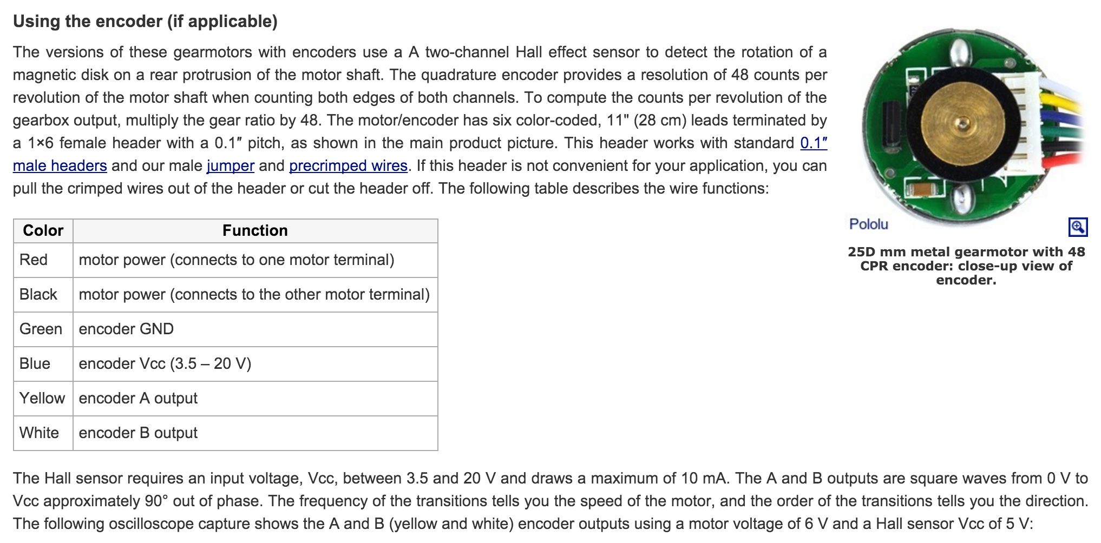

**RED and BLACK: plug those into 32u4 Motor Port 2 (the green screw-down header on the edge of the board).**

**Configure 2x3 header so that YELLOW and WHITE are along the edge and power and ground are in a column:**

